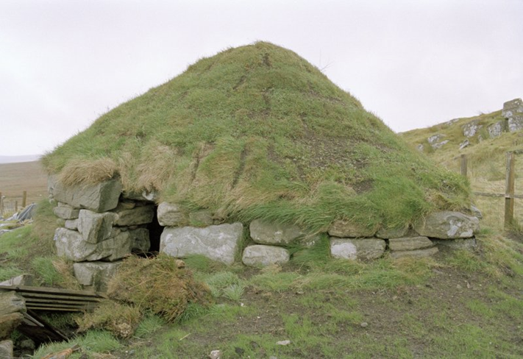
Reconstructed shieling hut, Isle of Lewis. Copyright Piers Dixon

ABSTRACTS FORM FOR THE RURALIA XIII CONFERENCE
“Seasonal Settlement in the Medieval and Early Modern Countryside”
Stirling (Scotland, UK); 9th – 15th September 2019

Titles and abstracts of not more than 200 words, with the name and affiliation of the contributor should be sent to Piers Dixon (piers.j.dixon@gmail.com) before 10th September 2018.
Surname, first name:
Country:
Tel:
E-mail:
Paper Yes/No | Poster Yes/No |  | Abstract included Yes/No
[Delete as appropriate]
Title of your abstract:
Abstract (200 words):

