RURALIA
European Association for Medieval and Post-Medieval Rural Archaeology

CALL FOR PAPERS
RURALIA XV CONFERENCE
“Farmers’ trade and markets. Social and economic interaction in the medieval and early modern European countryside”

Fredrikstad / Norway
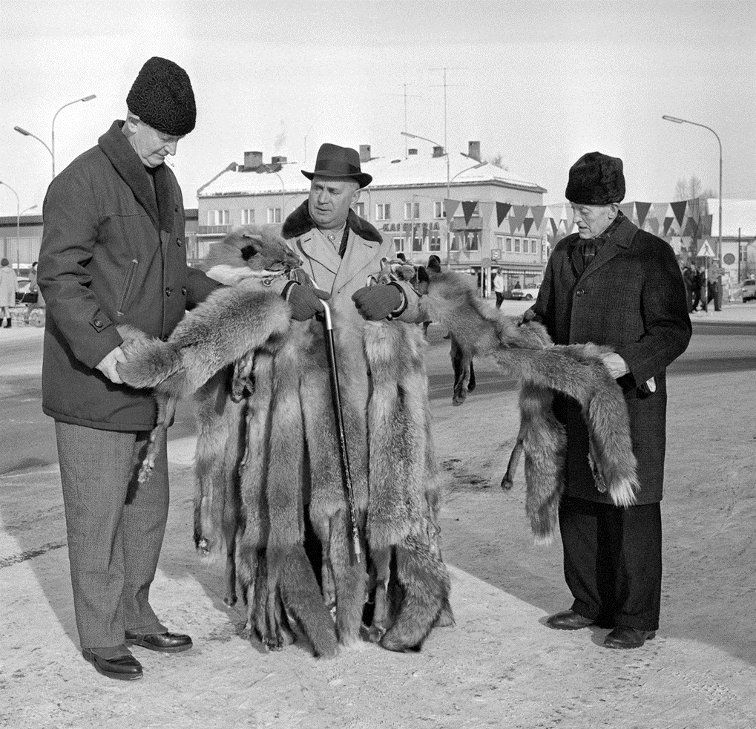
4th – 10th September 2023

RURALIA is an international association for the archaeology of medieval settlement and rural life. It provides a European-wide platform for the scientific exchange on current problems in rural archaeology in order to strengthen comparative and interdisciplinary studies. The conference covers the period from the Early Medieval to the Early Modern periods. The conference language is English.
RURALIA XV will take place in Fredrikstad, a city located in southeast of Norway. The theme is:
Farmers’ trade and markets. Social and economic interaction in the medieval and early modern European countryside.
In addition to the papers, one full day and one half-day excursion and an optional two-day field trip to sites in southeast Norway and eastern Sweden will be offered.
The conference is jointly organized by Marie Ødegaard, Kjetil Loftsgarden, Catarina Karlsson, Frode Iversen†, Mark Gardiner and Claudia Theune; with the support of Museum of Cultural History, Jernkontoret and Norwegian Archaeological Society.
Rural market- and meeting places, both periodic (fairs) and perennial (markets), were of great importance for social interaction and communication on a local and regional scale. It was essential for diffusion of innovations and ideas. The landscape, its prerequisites and possibilities, shaped people and technical systems to form a working combination. Interaction at meeting places shaped cultural norms, thoughts and identities, including norms for material culture.

Markets and informal trading places were parts of a larger economic and social whole, including trade and barter of goods, crafts and production ranging from artisans making jewellery to people making food and bread, accompanied by drinking, dancing, competitions and fights.

In rural areas there was a massive production of non-agrarian goods which made it possible for people to invest in surplus production and commodities. The elite was dependent on supply of resources, from agriculture as well as the outfield. An essential part of society was the command of resources, claimed through the organisation and control of trade routes and markets, and by alliances and social ties.

Human activity is linked to social relations, and the exchange of goods and services is integrated in cultural patterns and social strategies. It is also a part of the mechanisms of regionalization and the formation of a common culture and identity in the medieval and early modern period. We want to emphasise that we want to discuss non-urban markets.

Papers should address some of the following questions:
How were the rural market- and meeting places organised and by whom?
Which economic and social relations can be identified at market sites?
Can we identify local, regional, trans-regional or even global exchange?
How did trade and movement to markets among people shape the rural landscape?
What were the non-economic aspects of the meeting- and marketplaces?
What were the social significance of such sites, on a regional and inter-regional level?

Possible sub-themes:
- Uncovering the sites. How to find small-scale market- and meeting places, using archaeological and historical sources, place-names, etc.
- Traded goods. What were traded at the sites?
- Barter, credit, silver and coinage. How was the rural trade organised, and what were the practicalities of trade and exchange?
- Organising the rural market. How were the markets and market places organised. Who benefitted and who controlled the trade (if any)?
- Meetings, markets and the social impact. The non-economic side of meeting- and market places.

Please fill out the Abstract Form below if you wish to give a paper or poster at the conference.
Abstracts must be submitted by 31. January 2023. Proposals are subject to review by the organizing committee. Applicants will be informed of decisions by mid of February 2023.

Publication of the proceedings
The proceedings of RURALIA conferences are published in the RURALIA volumes, which appear every two years. The volumes are subject to full peer review and open access. It is expected that all presenters (papers and posters) will submit a paper for consideration in the volume. Papers will be new research and will not be previously published. Papers will not exceed 5000 words. Full instructions to authors are available on the RURALIA website, www.ruralia.cz
Papers and posters accepted for the conference cannot be considered for publication if the presenter is not in attendance at the conference.

Conference fees:
Conference + hotel + meals (full board) + 2 excursions (Monday-Friday) ....................... 650 € Accompanying person: double room, meals, excursions (Monday-Friday) .................... 510 €
Day delegate rate (conference + lunch) ……….................................................................. 60 € Optional Saturday and Sunday (excursion per person incl. 1 dinner) .............................. 50 €

Ruralia supports young researchers and tries to find financial support to lower costs. Please contact the organising committee on ruralia2023@gmail.com if that applies to you.

Important dates
31st January 2023 - Abstracts due, papers and posters.
Mid of February 2023 - Decisions on submissions made.
15 of March 2023 - 100 € non-refundable deposit per person and conference registration required.
1st June 2023 - Balance of conference fee due
31st January 2024 - Finished versions of papers to be submitted to the National Representative for peer review.

ABSTRACTS FORM FOR THE RURALIA XI VCONFERENCE
Fredrikstad / Norway / 4th – 10th September 2023
Farmers’ trade and markets. Social and economic interaction in the medieval and early modern European countryside

Titles and abstracts of not more than 200 words, with the name and affiliation of the contributor should be sent to ruralia2023@gmail.com before 31st January 2023.
Surname, first name:
Country:
Tel:
E-mail:
Paper Yes/No | Poster Yes/No |  | Abstract included Yes/No
[Delete as appropriate]

Title of your abstract:
Abstract (200 words):

