RURALIA
European Association for Medieval and Post-Medieval Rural Archaeology

CALL FOR PAPERS
RURALIA XVI CONFERENCE
Countryside and towns. Rural settlements in context of urban hinterlands in the Medieval and Modern Period

Kłodzko / Poland
8th – 14th September 2025
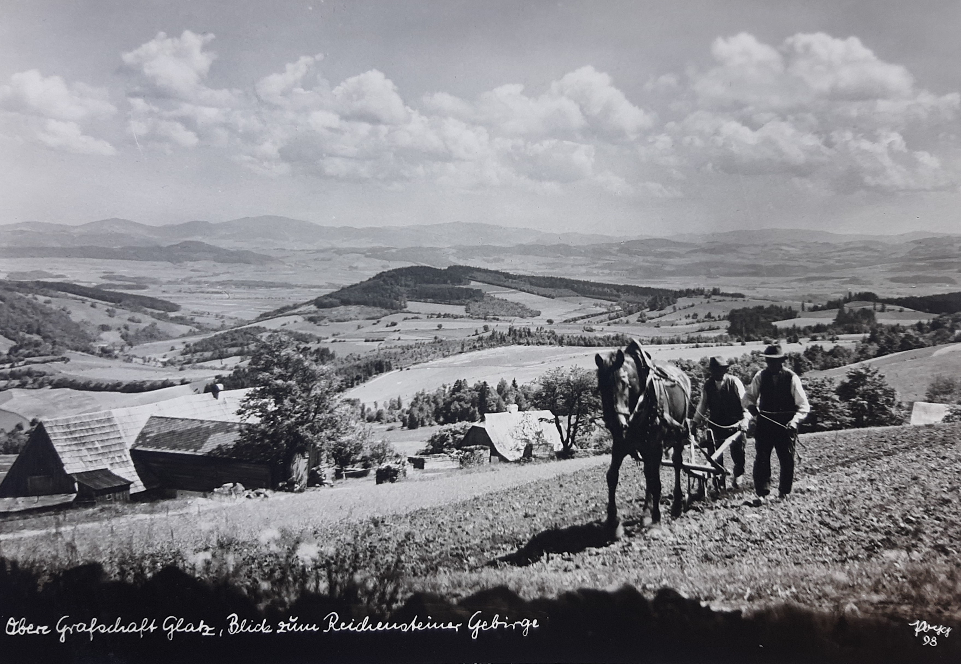
RURALIA is an international association for the archaeology of medieval settlement and rural life. It provides a European-wide platform for the scientific exchange on current problems in rural archaeology in order to strengthen comparative and interdisciplinary studies. The conference covers the period from the Early Medieval to the Early Modern periods. The conference language is English.
RURALIA XVI will take place in Kłodzko, a city located in southwest of Poland. The theme is:
Countryside and towns. Rural settlements in context of urban hinterlands in the Medieval and Modern Period
In addition to the papers, one full day and one half-day excursion and an optional two-day field trip to sites in southwest Poland and north Czechia will be offered.
The conference is jointly organized by Paweł Duma, Tomáš Klír, Maria Legut-Pintal, Jakub Sawicki, Catarina Tente and Claudia Theune; with the support of Museum of Kłodzko Region in Kłodzko (Muzeum Ziemi Kłodzkiej w Kłodzku), Municipality of Kłodzko, University of Wrocław and the science foundation, “Archaeologia Silesiae”.
Countryside and towns. Rural settlements in context of urban hinterlands
in the Medieval and Modern Period
The relationship between rural hinterlands and the towns can be characterised as a dialogue. Each town was dependent on external economic and population resources provided by its hinterland. At the same time, the town influenced the countryside. The metaphor that the rural settlements and its hinterland and the towns constituted one functional organism may sound banal; however, a look at the scholarship shows how often their research is separated and the interplay is neglected. The conference offers a platform to explore rural countryside impact in the urban environment, focusing on their connections and contrasts across diverse spatial and historical contexts. It will examine the transfer of knowledge, innovations, goods, products, institutions, and people, along with the infrastructure shaped by varying levels of territorial control and power structures that influenced rural regions differently. The perspective of this conference is the view from the rural landscapes to the town and not vice-versa.
The aim of the XVI Ruralia Conference is to investigate this issue from an archaeological perspective and its intersections with other disciplines. The conference invites papers, whether case studies or comparative analyses, that should address some of the following questions:
- What are the theoretical and methodological frameworks that current research is advancing? How does archaeological research conceptualise the relationship between towns and rural hinterlands?
- What spatial structures (size, zonality) characterise hinterlands? What are the characteristic archaeological patterns in the different zones? How do these reflect the behaviour of rural population? Periurban space as a specific zone.
- Landscape archaeological and environmental archaeological evidence. Opportunities and constraints.
- Socioeconomic structures and processes. How did rural settlements and landscape impact the socioeconomic structure of adjacent towns? How do archaeological sources contribute to the understanding of agrarian development, changes in settlement pattern, social structure, disintegration of peasant communities, commercialisation and monetisation?
- The impact of landownership and capital investment in the adjacent countryside (for example, demesne farms and burgess residences, the foundation of new settlements, ecclesiastical institutions).
- What were the relations between rural and urban crafts? Did they develop in parallel, or did rural crafts lag behind those in larger towns?

Please fill out the Abstract Form below if you wish to give a paper or poster at the conference.
Abstracts must be submitted by 31. January 2025. Proposals are subject to review by the organising committee. Applicants will be informed of decisions by end of February 2025.

Publication of the proceedings

The proceedings of RURALIA conferences are published in the RURALIA volumes, which appear every two years. The volumes are subject to full peer review and open access. It is expected that all presenters (papers and posters) will submit a paper for consideration in the volume. Papers will be new research and will not be previously published. Papers will not exceed 5000 words. Full instructions to authors are available on the RURALIA website, www.ruralia.cz
Papers and posters accepted for the conference cannot be considered for publication if the presenter is not in attendance at the conference.

Conference fees:
Conference + hotel + meals (full board) + 2 excursions (Monday-Friday) ............................... 550 € Accompanying person: double room, meals, excursions (Monday-Friday) ............................. 460 € Day delegate rate (conference + lunch) ………......................................................................... 60 € Optional excursion Saturday and Sunday ............................................................................. 280 €

Ruralia supports young researchers and tries to find financial support to lower costs. Please contact the organising committee on ruralia2025@gmail.com if that applies to you.

Important dates
31st of January 2025 – Abstracts due, papers and posters.
End of February 2025 – Decisions on submissions made.
15th of March 2025 – 100 € non-refundable deposit per person and conference registration required.
1st of June 2025 – Full payment of the fee
8th to 14th of September 2025 – Conference
31st of January 2026 – Finished versions of papers to be submitted to the Organizing Committee for peer review: ruralia2025@gmail.com

ABSTRACTS FORM FOR THE RURALIA XVI CONFERENCE
Kłodzko / Poland / 8th – 14th September 2025
Countryside and towns. Rural settlements in context of urban hinterlands in the Medieval and Modern Period
Titles and abstracts of not more than 200 words, with the name and affiliation of the contributor should be sent to ruralia2025@gmail.com before 31st January 2025.
Surname, first name:
Country:
Tel:
E-mail:
Paper Yes/No | Poster Yes/No |  | Abstract included Yes/No
[make a choise]

Title of your abstract:

Abstract (200 words):

